p.01 | p.02-1
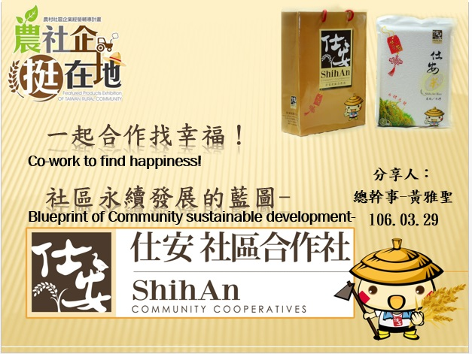 | 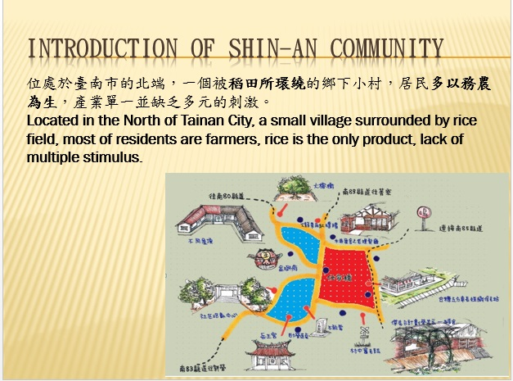
Members of the Executive, guests from Germany and community partners Hello! My name is Ya-Sheng, Huang, Now we want to share the blueprint of sustainable development of ShinAn community cooperatives. I hope you can know more about ShinAn and cooperatives and give us valuable advice and directive after presentation, thank you! | ShihAn, located in the north part of Tainan City which is surrounded by rice fields, like a small island floating in the rice sea, most of residents are farmers, lack of diverse industry stimulus.
各位長官、來賓以及社區的夥伴大家好!歡迎來到仕安社區，我是XXX  現在要分享的是我們仕安社區合作社的永續發展藍圖，希望在分享後能夠讓大家更加認識我們仕安及合作社，並給予我們寶貴的意見和指教，謝謝！ | 仕安，位處於台南市的北端，是一個被稻田環繞，如同浮沉在稻海中的一座小孤島，農民以務農為生，也因此缺少多元的產業刺激。

p.02-2 | p.03
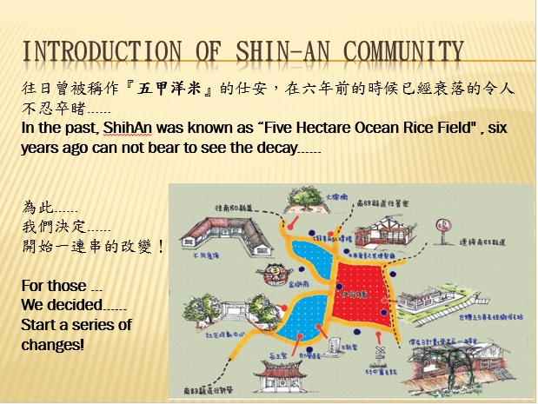 | 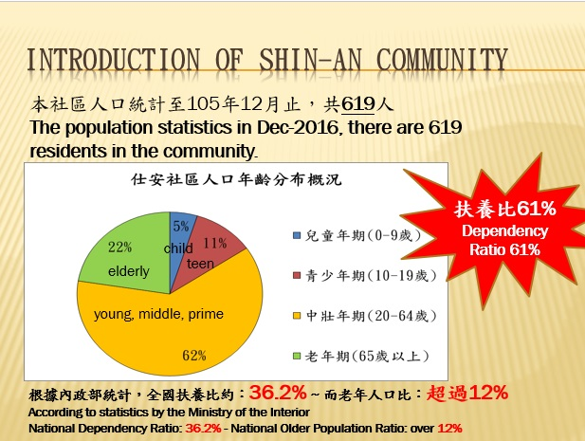
In Japanese era, this place was known as the "Five Hectare Ocean Rice Field" which was one of the rice field to offer tribute to Japan's emperor, but this place was forgotten by everyone for a long time and gradually decaying by lack of development. Six years ago can not bear to see the decay......  for those, we started a series of changes! | According to the statistics the population of this community in Dec-2016. There are 619 residents in the community and continueing decrease. The composition of population is more aging, elderly up to 22%, children and teenagers up to 16%, dependency ratio is up to 61%, almost doubled than national dependency ratio!
過去，在日本時代曾被稱為『五甲洋米』，是進貢給天皇的御用米產地之一，但如今卻早已被眾人所遺忘，也因為缺少發展而逐漸衰落，在六年前已經令人不忍卒睹。  因此，社區的居民開始一連串的改變！ | 這個社區的人口，至105年12月止，戶口登記只剩下619人，且還在持續銳減，而在組成上面更是高齡化，高齡者高達22%，在兒少上高達16%，也就是說有38%的被扶養者，扶養比高達61%，在全國平均值而言都快超過一倍！

p.04-1 | p.04-2
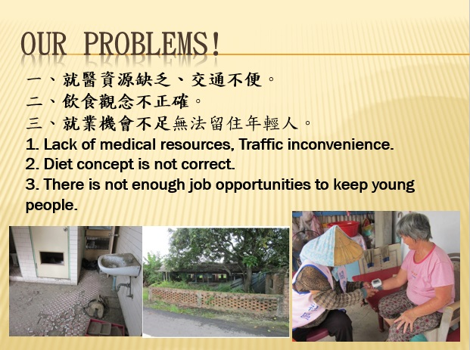 | 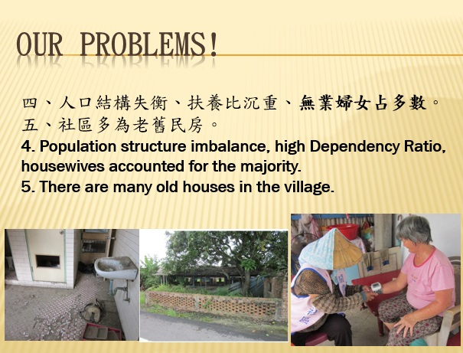
So we started looking our problems and found several situations.  1. Absence of medical resources and traffic inconvenience, not a good choice for living.  2. Incorrect diet concept of elderly. Because the saving money reason. Elderly often cook one time to eat several meals which is harm for health.  3. Lack of multiple job opportunities, young people can't stay in hometown. | 4. Population structure imbalance resulting heavy dependency ratio and there are a large number of housewives that without proper job opportunity for them.  5. There are many old houses and space has not been effectively used in the community.
所以我們開始尋找問題並發現到幾個狀況  第一個就是附近沒有醫療資源，而且交通不便，對於居住來說不是很好的選擇  第二個是長輩的飲食觀念問題，因為節省的緣故，常常煮一餐吃好幾次，但對於健康來說是很大的傷害  第三個是因為沒有多元的就業機會，年輕人無法留下來 | 第四個就是人口結構失衡，所以造成扶養比沉重，而其中有大量的無業婦女，卻沒有適當的機會讓她們發揮  第五個就是社區有大量的老舊房屋和空間沒有被有效使用

p.05-1 | p.05-2
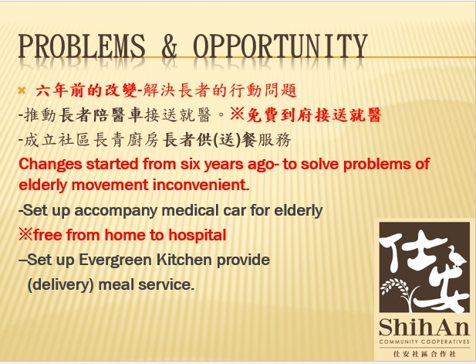 | 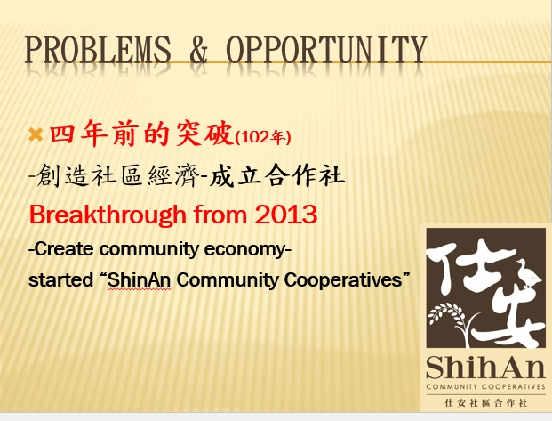
Then we began to change. Six years ago we promoted service of accompany medical car for elderly. Residents can have a free shuttle service as small as take medicine from pharmacy or health examination in hospital, just need one call, you can take a free ride from home to hospital to solve traffic inconvenient problems .  We also promote community kitchen, prepared by volunteers of mothers to provide or delivery lunch for elderly. Feelings and relationships of community residents are pulled together by that. | But two years later, we found that these benefits can not sustain by donations and subsidies. So we decided to set up community economies to maintain community welfare, that is the reason we set up a cooperatives.
所以我們開始改變，六年前開始推動陪醫車的服務，讓社區居民可以有免費的接送就醫，小至藥局拿藥，大至醫院檢查，只要一通電話，就可以到府上接送，讓交通不便的問題被解決 也推動了社區廚房，由志工媽媽們一起準備，提供長輩們中午到社區用餐，如果有行動不便者或獨居者，則會打便當送到他們家，把整個社區的感情和關係都拉在一起了。 | 但是，兩年後，我們發現這些福利只靠捐款和補助是無法永續的，所以我們決定成立社區的經濟體，讓社區的福利自己可以維持下去，因此我們成立了合作社

p.05-3 | p.06
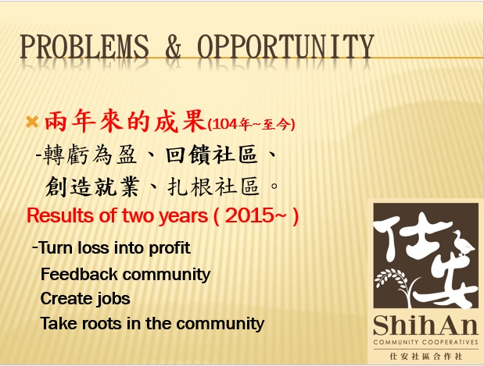 | 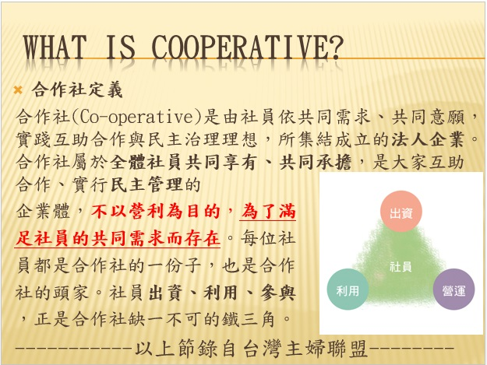
The initial stage of the establishment was continuous loss, but we still insisted, finally turn loss into profit after two years, and it now can feedback to community and creat employments, and we try to take roots in the community, so that everything can move to sustainable development. | what is cooperatives? besides the reference in PPT contents, the most important point is that our exist is not for the purpose of private profit, but in order to meet the common needs of members, because we want this community better and better!
從一開始成立後的連續虧損，但我們持續的堅持，終於在兩年後轉虧為盈，並走到如今能夠回饋社區並創造就業，而我們也開始試著扎根，讓這一切能夠朝著永續發展。 | 合作社是什麼？這邊除了參照簡報上的內容外，最重要的一點就是，我們不是以私人營利為目的，而是為了滿足社員們的共同需求而存在，因為我們要的就是能夠讓社區變得更好！

p.06-2 | p.07-1
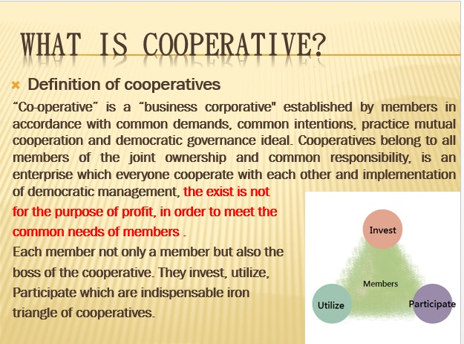 | 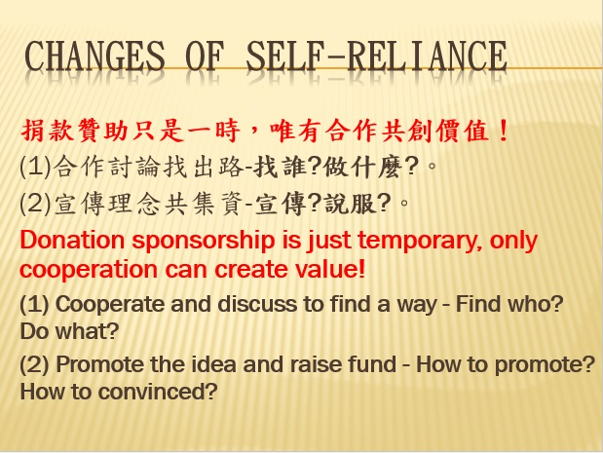
 | So, we wanted to set up a cooperatives with residents who accepted our ideas , and discussed together what kind of industry that we wanted to develop. We promoted our ideas door by door and got supports by many residents.
無 | 所以我們想與認同這個理念的居民共同成立合作社，並一起討論要發展什麼樣的產業，我們挨家挨戶的和大家宣傳，並取得許多居民的認同。

p.07-2 | p.08-1
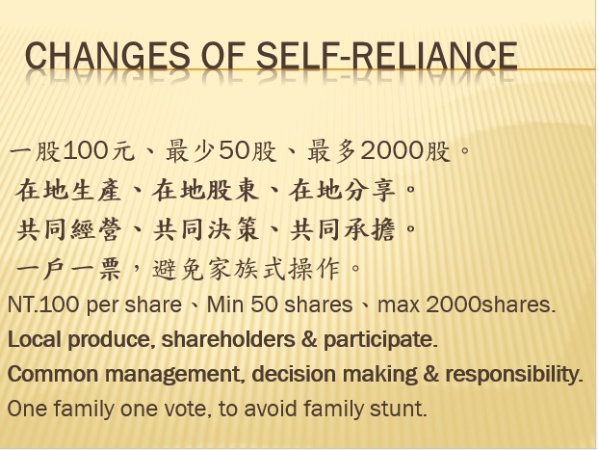 | 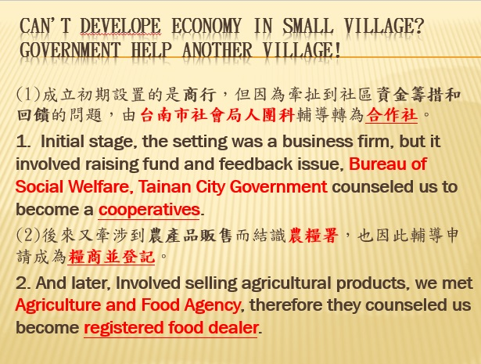
Each share is NT.100, Max is 2,000 shares, only for resdients, one family one vote to avoid family stunt, therefore, we had 55 memebers in the first time and raised NT.2.16 million of established fund. | It is also because of self - reliance and self - improvement, we have been assisted by many government departments, such as Bureau of Social Welfare, Tainan City Government; Agriculture and Food Agency; Taxation Bureau; Soil and Water Conservation Bureau; Tainan Branch of Soil and Water Conservation Bureau and Yunlin-Chiayi-Tainan Regional Branch Workforce Development Agency, MOL...etc, help us to solve problems of transformation, registration, construction, equipments, manpower and other issuses. we are here again thanks to their help!
所以我們用一股100元，最多2000股，並以在地居民為主，且以一戶一票的方式避免投票上出現壟斷，也因此，我們在第一次的成立時就找到55名社員，並集資了216萬做為我們的成立的基金。 | 那也因為自立自強的關係，我們前後受到許多政府部門的協助，像是台南市社會局、農糧署、國稅局、水保局總局和台南分局以及勞動部雲嘉南分署等，接連的幫我們解決了轉型、登記、建設、設備、人力等問題，我們在這邊再次感謝他們的協助！

p.08-2 | p.08-3
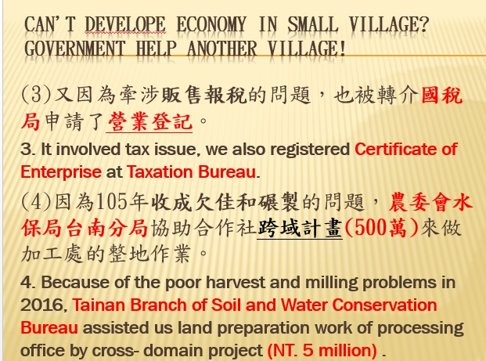 | 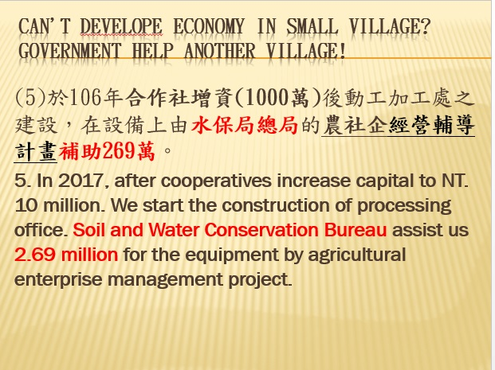
無 | 無

p.08-4 | p.09
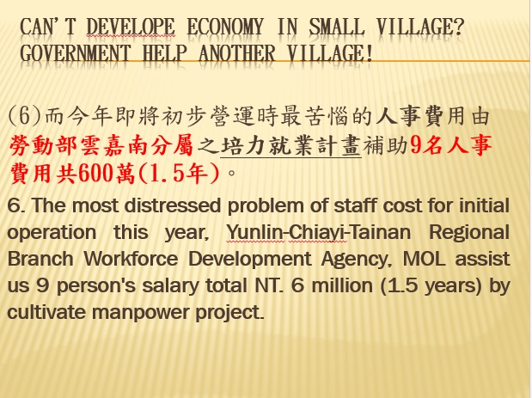 | 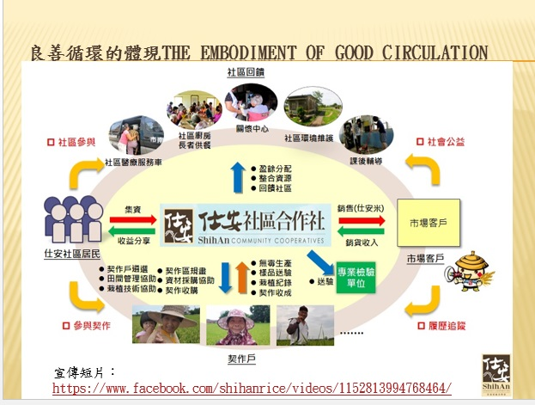
 | This is the circulation map of operation of cooperatives, invest and set up by residents, we looked farmers whom have willing to change their farming method, unified inspection by our cooperatives, packaging and marketing. The profit will be back to farmers, community and residents which become a well circulation.
無 | 這就是合作社的運作循環圖，由居民投資成立，並尋找願意改變耕作方式的農民契作，由合作社統一送檢驗，然後包裝行銷，將所得回饋到農民、社區和居民，變成一個良善的循環

p.10-1 | p.10-2
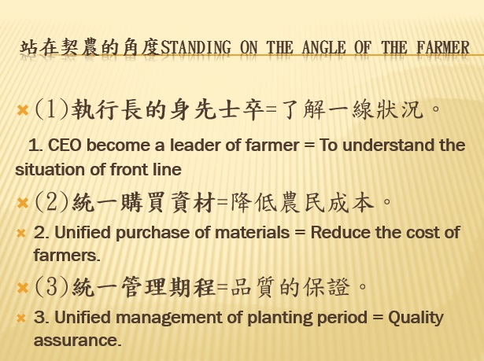 | 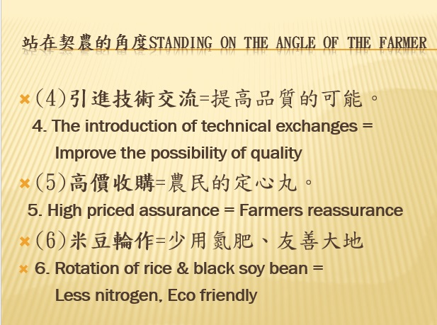
Our CEO always work together with farmers in the first line, unified purchase of materials to reduce the cost of farmers and unified management of planting. | The technical level also introduced the assistance from Agricultural Research and Extension Station, COA and Homemakers Union Consumers Coopratives. We pay 40% higher price than market price and buy ensurance 80% quantity of output to achieve the spirit of fair trade. Farmers can reassurance to cooprate with us, no longer suffer from natural disaster, pests and diseases of crop. Rotation of rice & black soy bean to make land rest and friendly land!
對於契作農民，我們的CEO總是在第一線和他們一起耕作，而且我們統一購買大量資材來降低農民的成本，並給予統一的管理 | 而技術層面也引進農改場和主婦聯盟的協助，並以高於市價40%的價格和保證8成產量的收購方式來達到公平貿易的精神，讓農民可以安心地和我們合作，不再被天災蟲害所苦，並且採用一期稻米、二期黑豆的方式來讓土地休養，友善大地！

p.11-1 | p.11-2
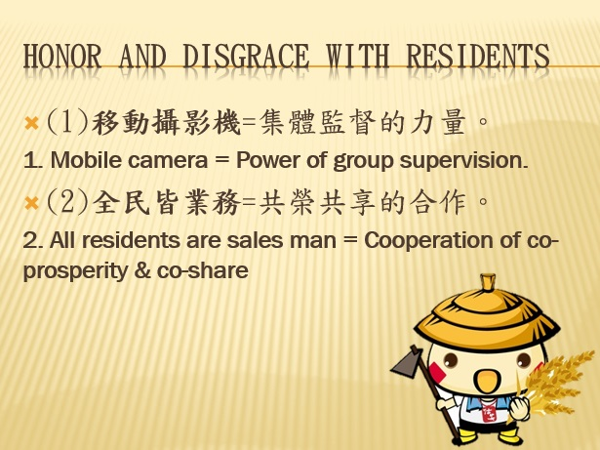 | 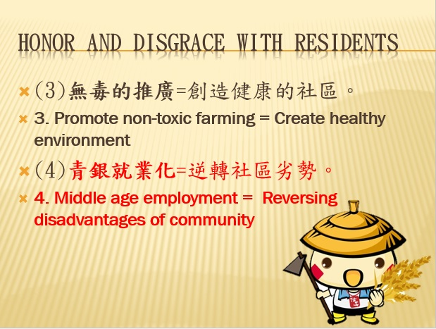
Each of our residents and shareholders is a monitor who supervising our operation and farming way of farmer. It is the only way to move forward in the right direction and work together to marketing our products that is the reason of sustainable community welfare. | We finally hope that the community will become a non-toxic healthy environment. Make disadvantage - high dependency ratio of population into productive advantage, cooperatives begin to provide jobs opportunities for these groups.
我們的每一位居民和股東都是監視器，監督著我們的運作和農民的施作，唯有如此才能朝著對的方向前進，並且群策群力的共同行銷我們的產品，因為這樣才能讓我們的社區福利得以永續。 | 我們最後也希望讓社區變成無毒健康的環境，並且將原本的劣勢-人口高扶養比的問題變成具備生產力的優勢，所以合作社開始提供工作機會給這些族群。

p.12-1 | p.12-2
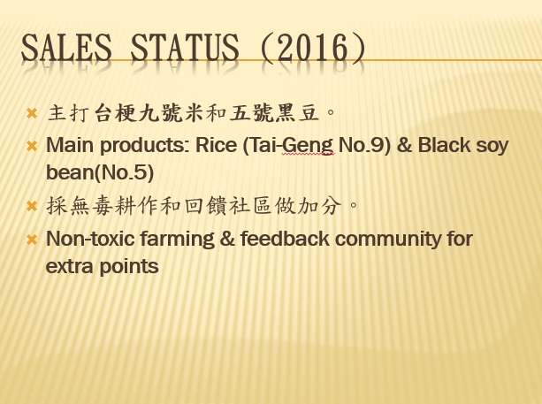 | 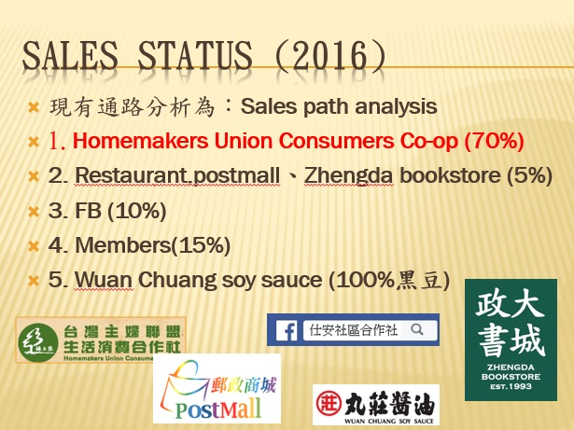
Our main products are TaiGeng No.9 of Rice & Black soy bean(No.5), Our biggest selling point are use non-toxic farming method and spirit of feedback to community to get agreement and support from consumer. | Our main sales channels are Homemakers Union Consumers Co-op, Wuan Chuang soy sauce and network platform.
我們現在的主打產品是台梗九號和五號黑豆，而我們最大的賣點就是採用無毒耕作和回饋社區的精神來讓消費者認同和喜歡。 | 而現在的通路主要是以主婦聯盟及丸莊醬油的合作，加上一些網路平台的銷售。

p.13 | p.14
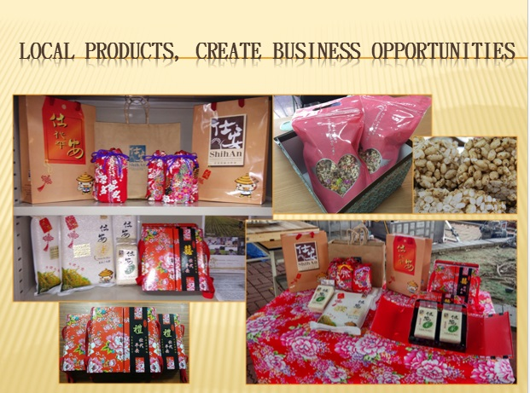 | 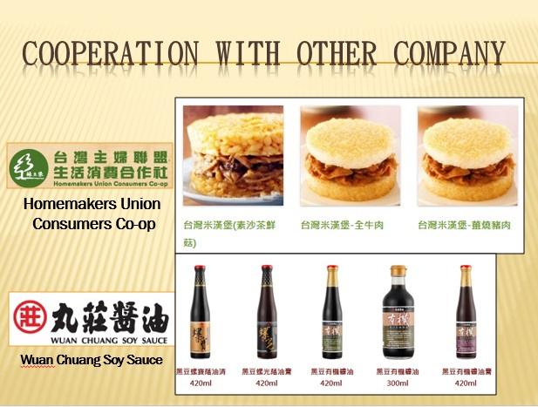
These are our current products. And of course new products we shown today is still in development. | These are co-manufacturers products which are rice burgers with Homemakers Union Consumers Co-op can be eaten after microwave, and products with Wuan Chuang soy sauce.
那這些就是我們目前的商品，當然還有我們今天展示出來的這些研發中新產品。 | 而這些是合作廠商的商品，主婦聯盟的米漢堡，只要微波後就可以食用，以及丸莊醬油的商品

p.15 | p.16
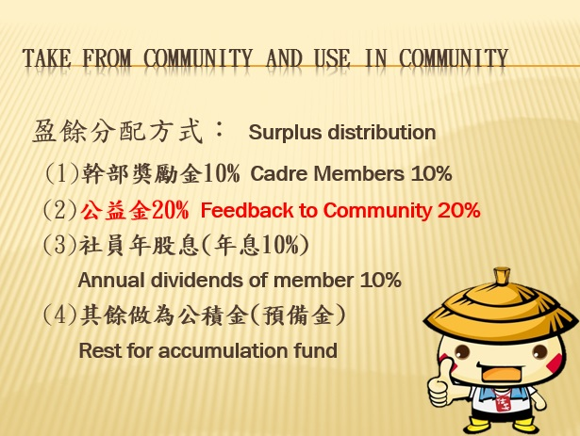 | 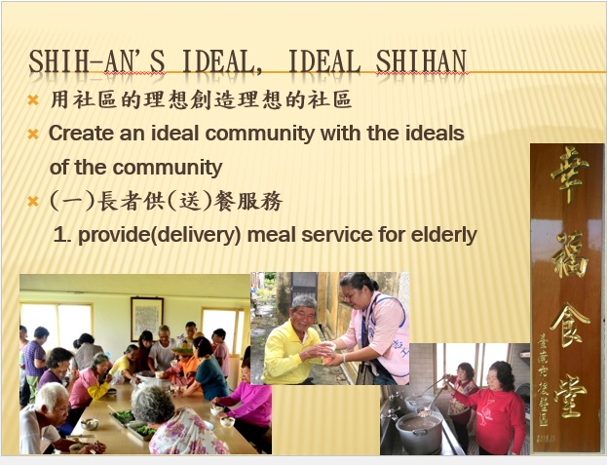
Distribution and feedback of surplus: 10% of surplus for cadre members split equally, 20% for feedback to community, 10% for annual dividends of members, rest for accumulation fund. | We create an ideal community with our ideals. This is the situation of providing and delivering meal service for elderly.
我們的分配與回饋上，給予我們這些管理幹部10%的部分平分，而社區回饋上是20%，給予股東社員們是利息10%，其他的部分留作公積金來維持合作社的運作。 | 我們用自己的理想來創造理想的社區，這就是大家一起到活動中心用餐的狀況。

p.17 | p.18
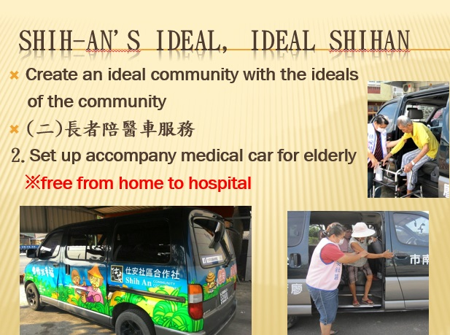 | 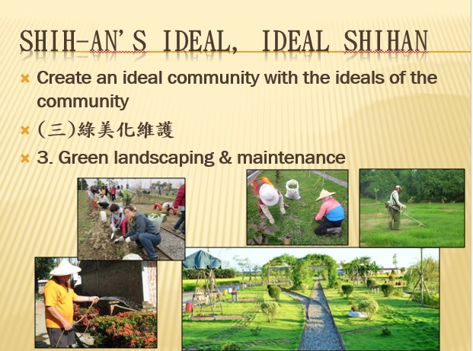
This is our accompany medical car for elderly. allow residents make an appointment on every Monday, Wensday, Thursday and Friday. | Maintaining green landscaping and environment, make more suitable for living.
這是接駁車的部分，提供每週一、三、四、五來讓居民預約使用。 | 以及維持社區的美化環境，讓這裡更適合居住。

p.19 | p.20
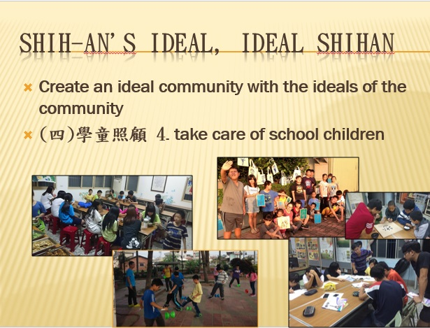 | 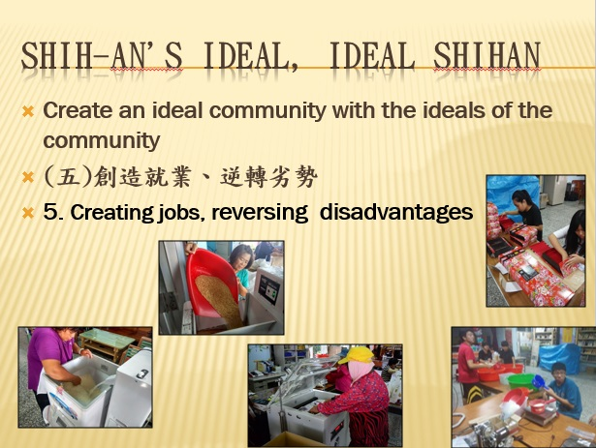
In order to make our children have more memories of their own community, we have after-school care and multi-course services, so that children have more recognition and feelings of community. | Job opportunities from cooperatives help unemployed women and young man to earn money. Also indirectly let dependen one become independent one.
為了讓社區的孩子對自己的社區更有記憶，我們舉辦課後照顧和多元課程的服務，讓孩子們對自己的社區更有認同和感情。 | 並由合作社來釋放出工作機會，讓無業婦女和年輕人有機會貼補家用，也間接讓被扶養的人變成有辦法自立。

p.21 | p.22
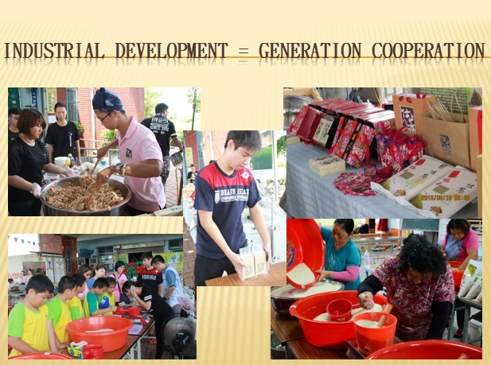 | 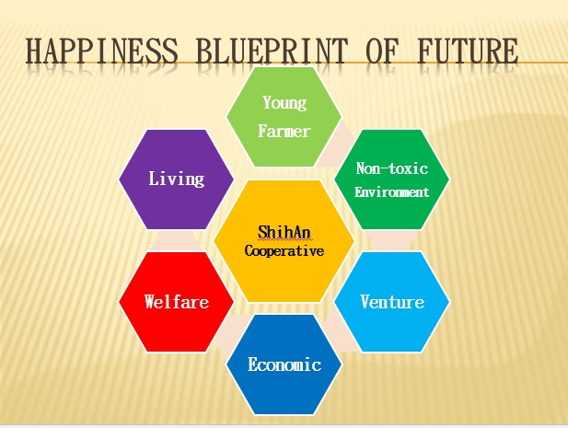
What we expect is to let more people share the benefits of cooperatives, whether it is the promotion of food-agriculture education, young employment opportunities and elderly re-employment, to acchive more helping things by cooperatives. | Happiness blueprint of cooperatives are: have more young farmers, promote non-toxic farming method, creat job opportunities, enhance the overall economic power, sustainable community welfare, make ShinAn into a livable home, the only way to cut off collapse of population outflow, creat legend of ShinAn.
我們期待的就是讓更多人分享到合作社所帶來的好處，不管是食農教育的推廣、青年打工(就業)的機會、長輩們的再就業，用合作社來完成更多幫助人的事情。 | 合作社的幸福藍圖就是，讓青農回流、推廣無毒栽種、創造就業機會、提升整體經濟力、永續社區福利、讓仕安變成宜居家園，唯有如此才能斬斷人口外流的崩潰，再創仕安的傳說。

p.23
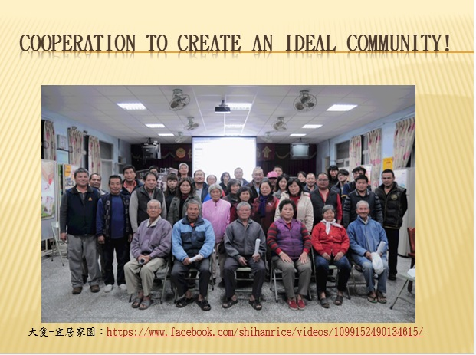
From self - reliance and self - improvement of community development to recognition of civil society groups and government departments. We met too many partners and assists. Self-help, people-help and then gods help. The happiness of ShihAn blueprint is still drowing, for a better community, helps more people. thanks for the guests who are here today, thank you!
一路走來，從自立自強的社區發展，到民間和政府的認同，我們遇到太多志同道合的夥伴和幫助，因為自助而人助到天助，仕安的幸福藍圖還在繼續撰寫著，因為想要的就是讓社區能夠更好，幫助更多的人。感謝今天與會的各位來賓，謝謝！

